Creating databases

Objectives
At the end of this session, the student will be able to:
- Create databases
- Edit the options in database setting
- Alter and drop database
CREATE DATABASE DATABASE_NAME
[ ON
[ PRIMARY ] [ <filespec> [ ,...n ]
[ , <filegroup> [ ,...n ] ]
[ LOG ON { <filespec> [ ,...n ] } ]
]
[ COLLATE collation_name ]
]
[;]

Part I –
Context :
St. Paul’s Training Institute is a training institute located in Los Angeles, USA. The institute provides training in various courses in different fields such as science, mathematics, and so on.
The institute want to develope a Student Management System to manage the student and staff details. To develop the system, the first task is developing a database which store it ‘s data.
Use Microsoft SQL Server , you have to accomplish developing the database.

Exercise 1 : Creating and managing database by Microsoft SQL Server Management Studio
- Create database :
- In the “ Object Explorer” window, right click on “Database” item, select “New Database” as shown in the figure 1:
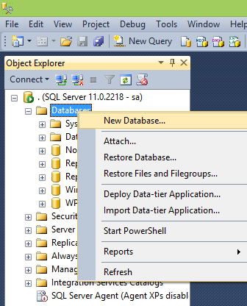
Figure 1

- This will open “New Database” dialog as shown in Figure 2. The dialog allow user to enter database name, select the owner, modify logical name, set size and path of database file and log file …
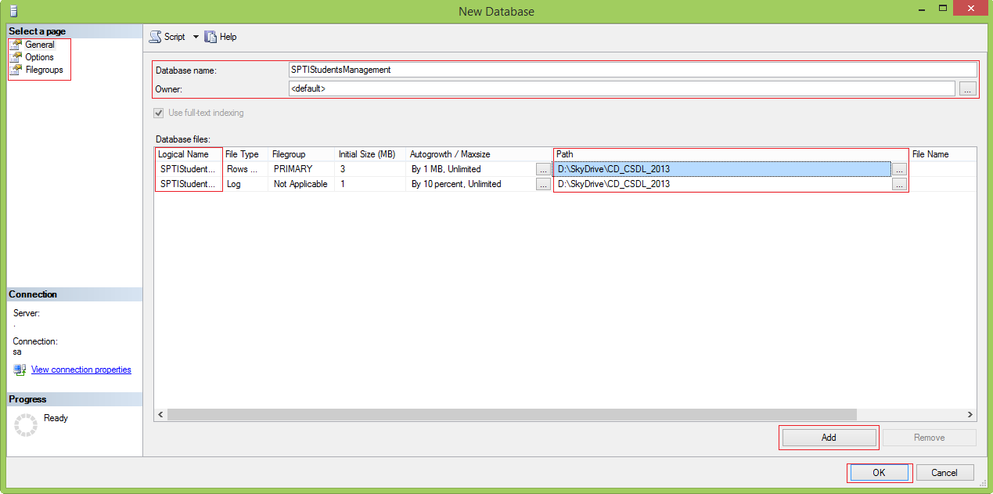
Figure 2

- User can change options of database in the “Options” tab in Figure 3 :
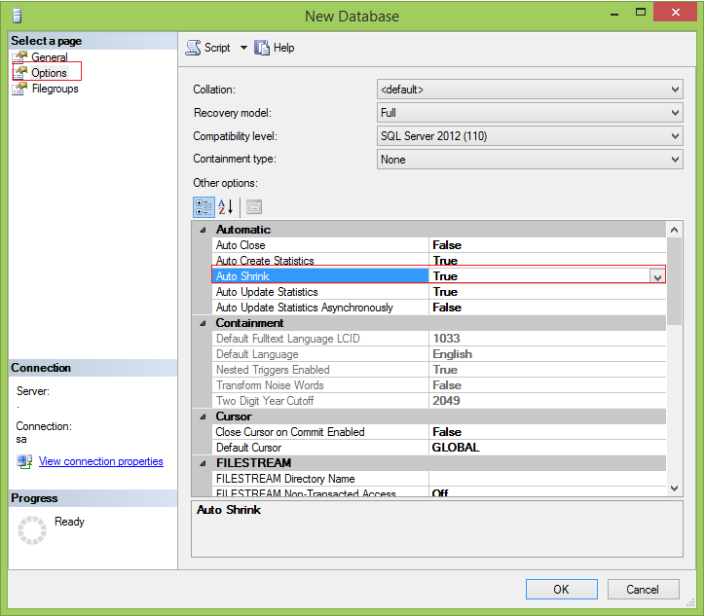
Figure 3

- User can change the filegroups which will store the database file in the “Filegroups” tab as shown in the figure 4.
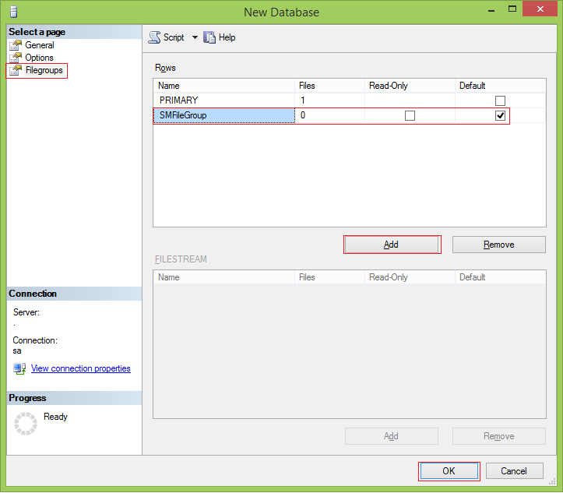
Figure 4

- After setting all the necessary options, user click “OK” button in the “New Database” dialog to finish creating database as Figure 5.
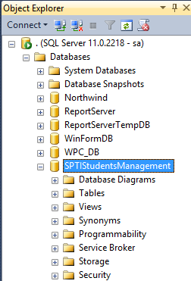
Figure 5

- Modify database :
Modify the SPTIStudentsManagement database to add database files to SMFileGroup, create a data file SPTIStudentsManagement_2, and a log file SPTIStudentsManagement_Log_2. Also set the AUTO_SHRINK option to ON state
- In the “ Object Explorer” window, right click on the SPTIStudentsManagement database, select “Delete” as shown in the figure . The “Database Properties” diaglog will be shown.
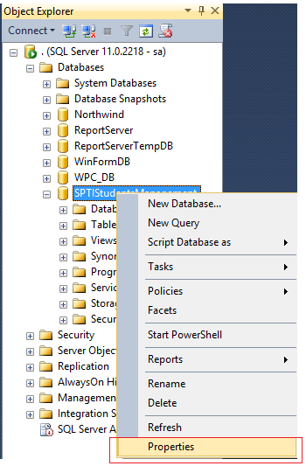
Figure 6

- Choose “Files” tab, add a data file and a log file. Choose the filegroup for the data file as Figure 7.
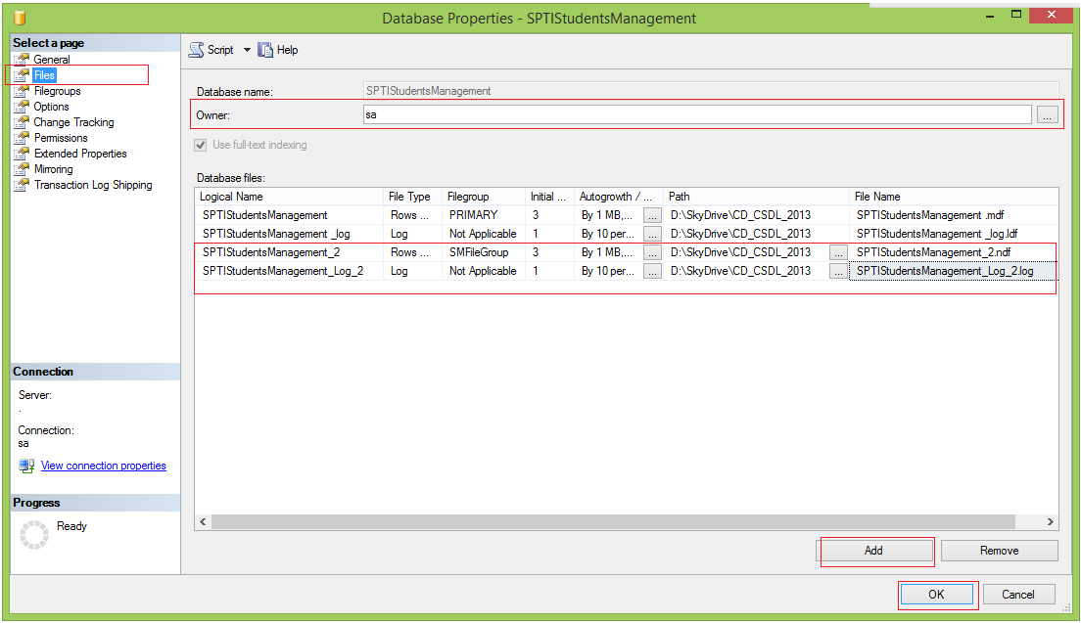
Figure 7
- Choose “Options” tab, set the Auto-shrink property value to True as Figure 8
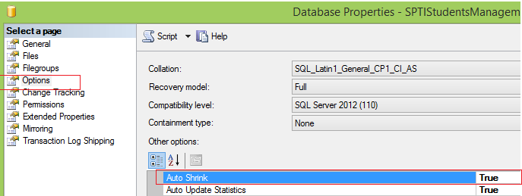
Figure 8

- Drop database :
- In the “ Object Explorer” window, right click on the SPTIStudentsManagement database, select “Properties” as shown in the figure 6. The “Database Properties” diaglog will be shown.
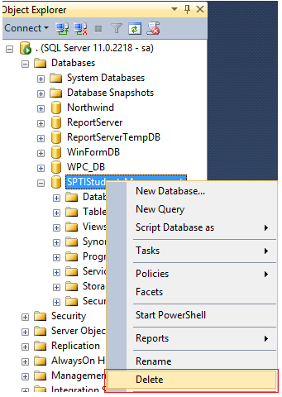
Figure 9

Exercise 2 : Creating and managing database by SQL statements
You have to use the SQL statements to do the following tasks :
- Create database named SPTIStudentsManagement with default options.
CREATE DATABASE SPTIStudentsManagement
- Drop the SPTIStudentsManagement database.
DROP DATABASE SPTIStudentsManagement
- Create SPTIStudentsManagement database with special database file and transaction log file (in any user disk)
CREATE DATABASE SPTIStudentsManagement
ON PRIMARY
(NAME=N'SPTIStudentsManagement',
FILENAME = N'D:\SkyDrive\CD_CSDL_2013\SPTIStudentsManagement.mdf',
SIZE =10MB, MAXSIZE = UNLIMITED, FILEGROWTH =1MB)
LOG ON
(NAME=N'SPTIStudentsManagement_Log',
FILENAME=N'D:\SkyDrive\CD_CSDL_2013\SPTIStudentsManagement_Log.ldf',
SIZE =3MB, MAXSIZE = 2048GB, FILEGROWTH =10%)
- Rename SPTIStudentsManagement database into StudentManagement database.
ALTER DATABASE SPTIStudentsManagement
MODIFY NAME = StudentManagement
- Set the StudentManagement database allowing auto shrinking.
ALTER DATABASE StudentManagement
SET AUTO_SHRINK
- Create a data file named StudentManagement.ndf and add it to the « SMFileGroup » group which stores the database file of StudentManagement database.
ALTER DATABASE StudentManagement
ADD FILEGROUP SMFileGroup

ALTER DATABASE StudentManagement
ADD FILE
(NAME = 'StudentManagement', FILENAME=N'D:\SkyDrive\CD_CSDL_2013\StudentManagement.ndf')
TO FILEGROUP SMFileGroup
- Create database snapshot for StudentManagement database
CREATE DATABASE StudentManagement_Snapshot ON
(NAME='SPTIStudentsManagement', FILENAME=N'D:\SkyDrive\SPTIStudentsManagement.ss'),
(NAME='StudentManagement', FILENAME=N'D:\SkyDrive\StudentManagement.ss')
AS SNAPSHOT OF StudentManagement

Part II – 30 Minutes
Exercise 3 : Create SELL_MANAGE database.
Create a database named SELL_MANAGE with the requirements :
Logical Data File Name | SELL_MANAGE
Data File Size | 500MB
Maximum Data File Size | 10GB
Data File Growth Inscrement | 50MB
Logical Log File Name | SELL_MANAGE_Log
Log File Size | 100MB
Maximum Log File Size | 1GB
Log File Growth Inscrement | 10MB

Part III – Do it yourself
Exercise 4 :

- Create a database named UnitedAir using T-SQL statements with the following properties :
- Primary file group with files, UnitedAir1 and UnitedAir2. The size, the maximum size and file growth should be 5, 10, and 15% respectively.
- A filegroup named UnitedAirGroup1 with the files UnitedAirGrp1GF1, UnitedAirGrp1GF2
- A filegroup named UnitedAirGroup2 with the files UnitedAirGrp2GF1, UnitedAirGrp2GF2
- Create a database snapshot for the database, UnitedAir

